Machine Learning Assignment on Fashion MNIST Dataset

1. Downloading the Fashion-MNIST Dataset

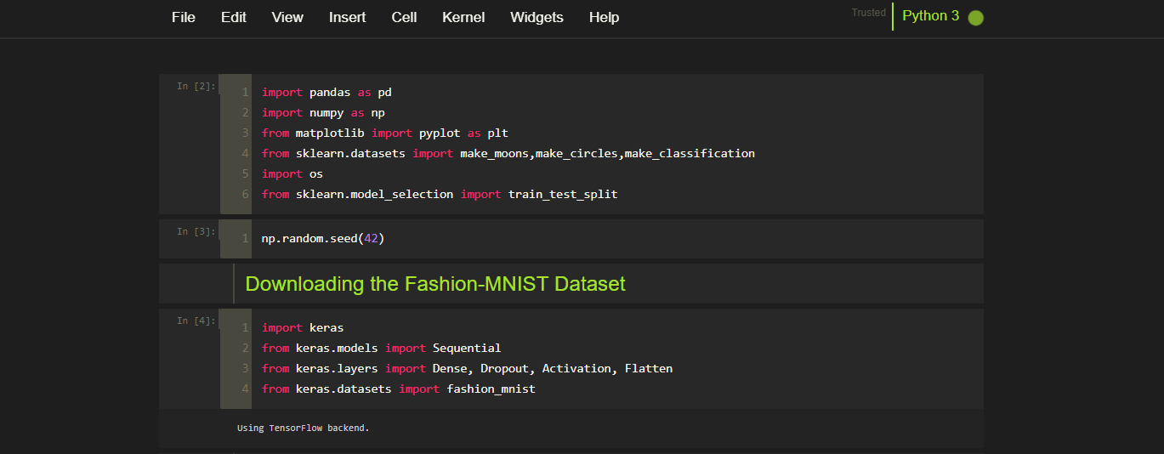

1. Data Pre-Processing

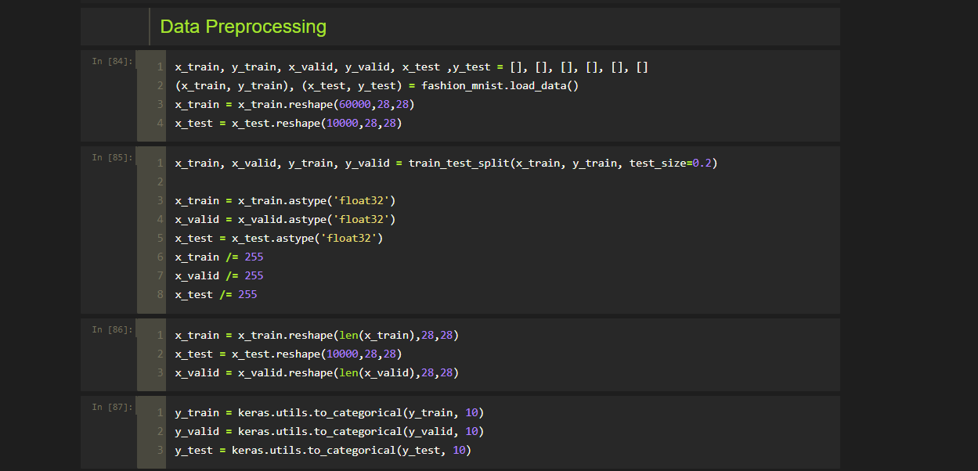

1. Building the 1st MLP model

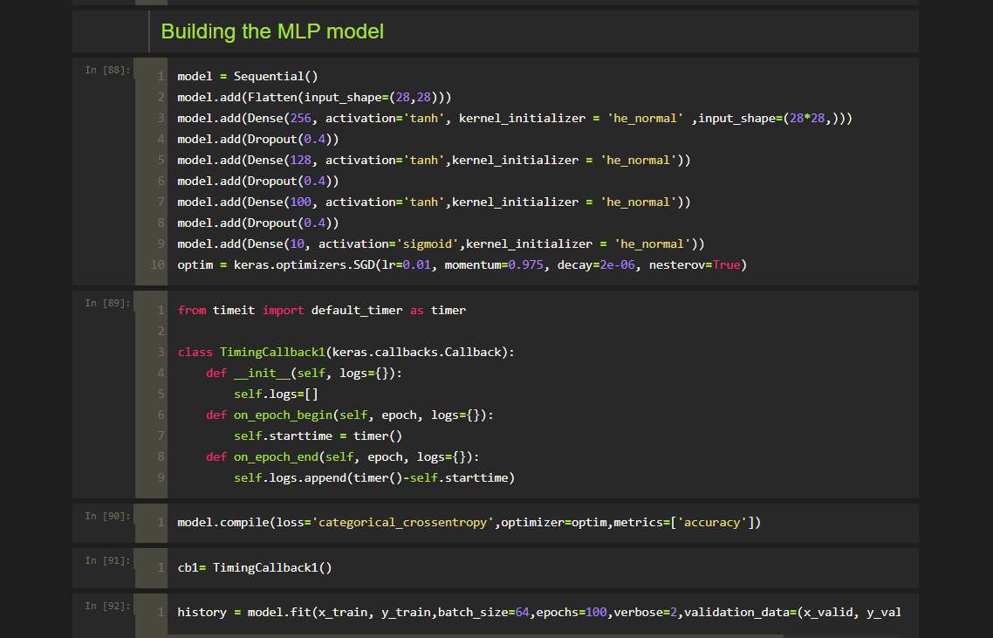

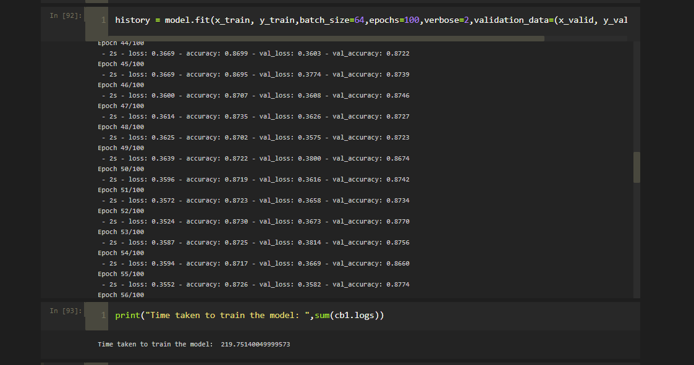

Accuracy of 1st model

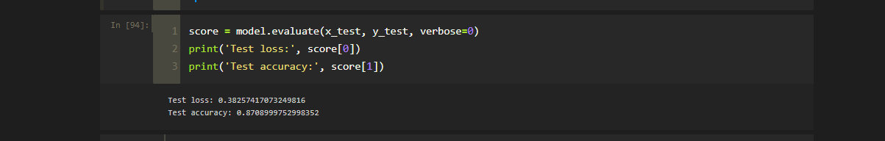

1. Building the 2nd MLP model varying the number to neurons

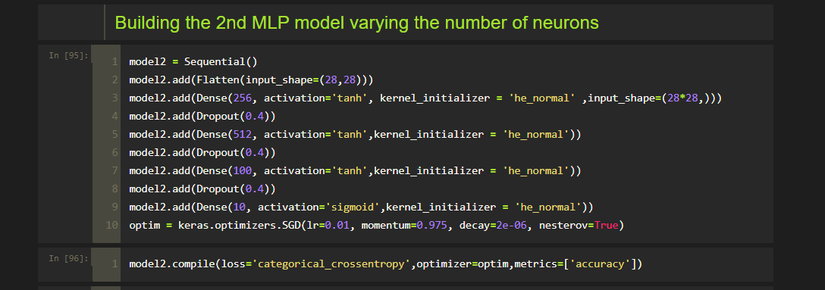

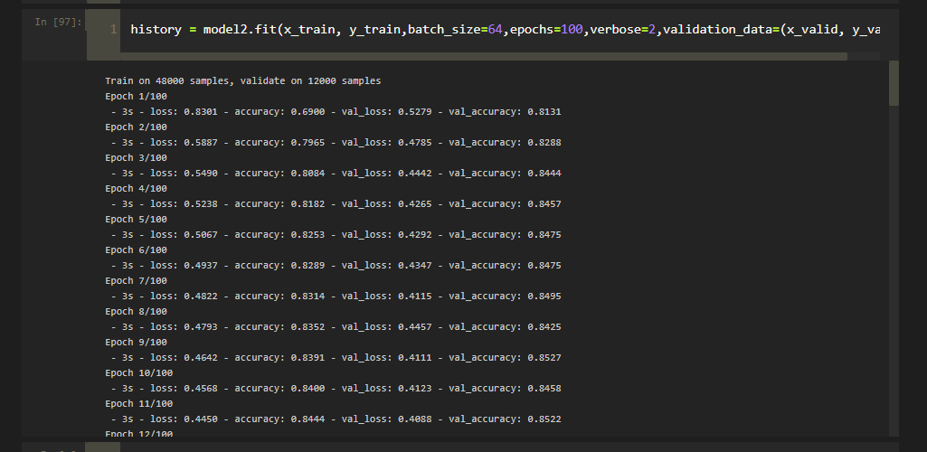

Accuracy

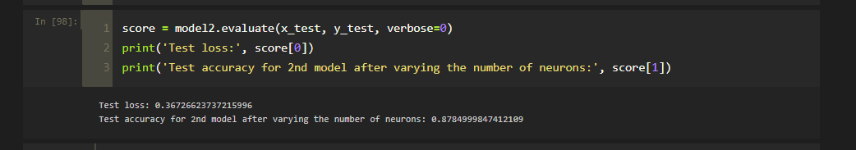

1. Comparing the results of both the models

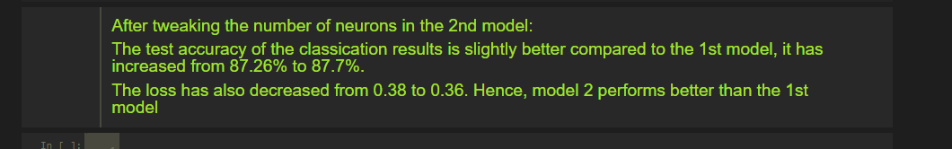

1. Dimensionality Reduction using PCA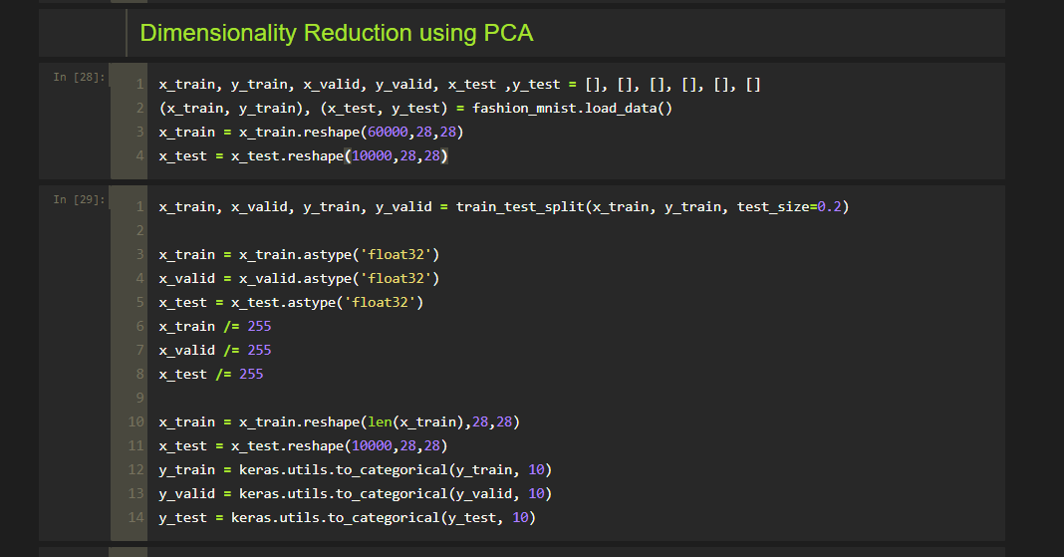

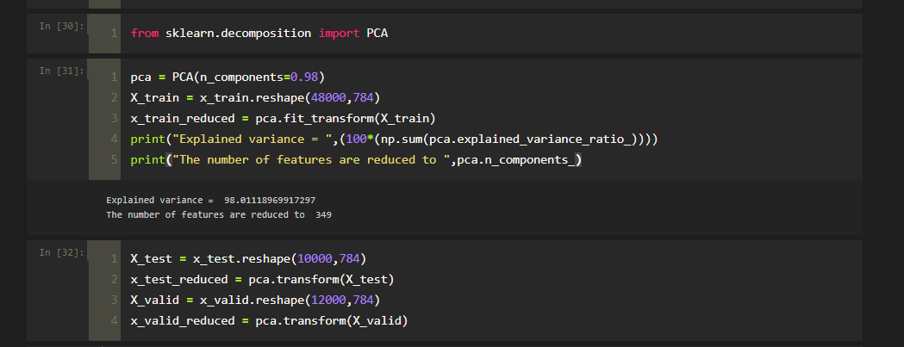

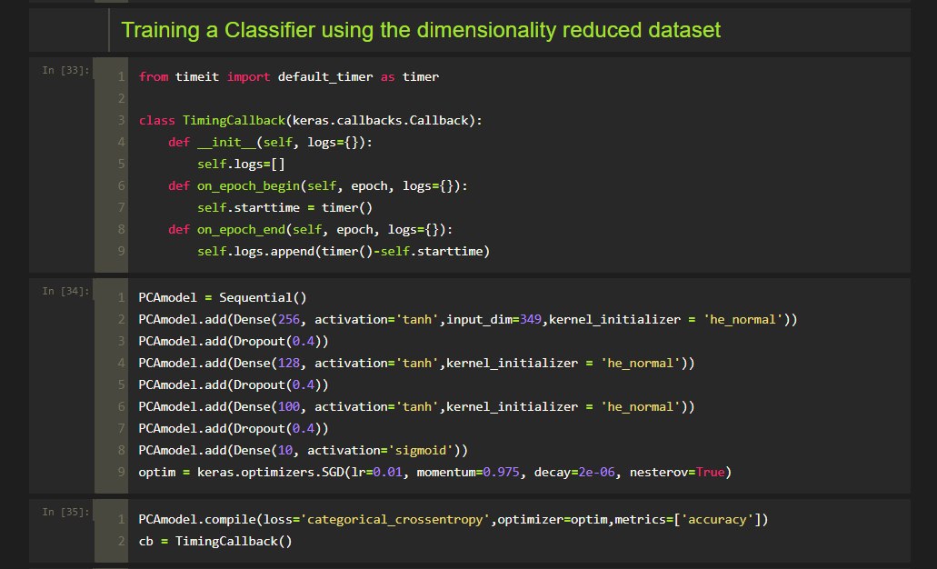

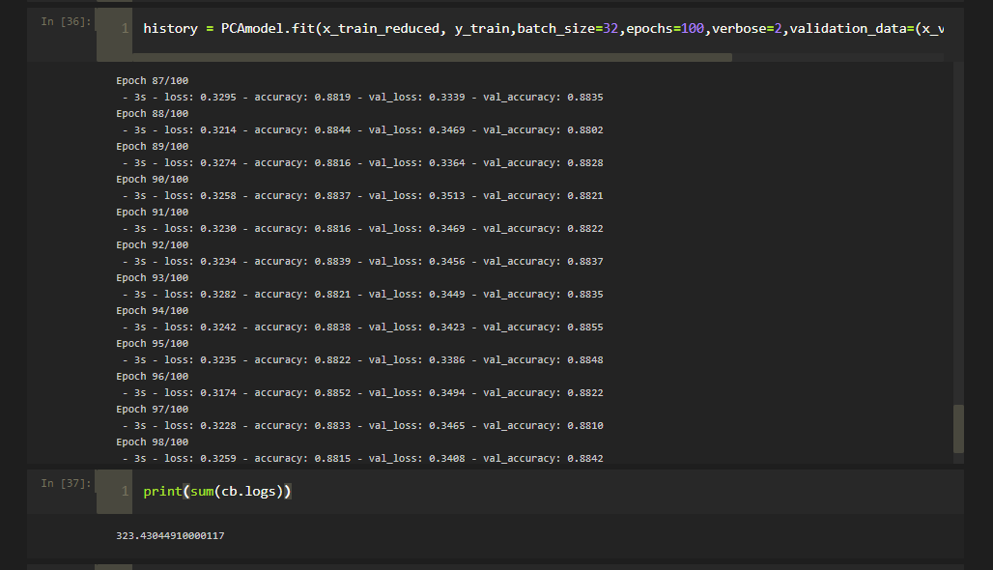

Accuracy

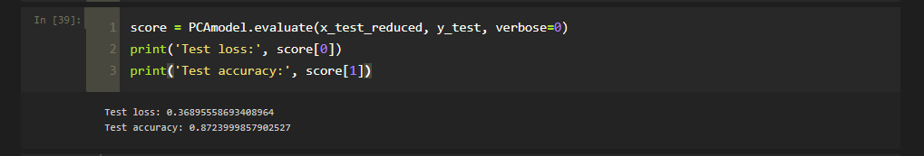

1. Comparing results with original model

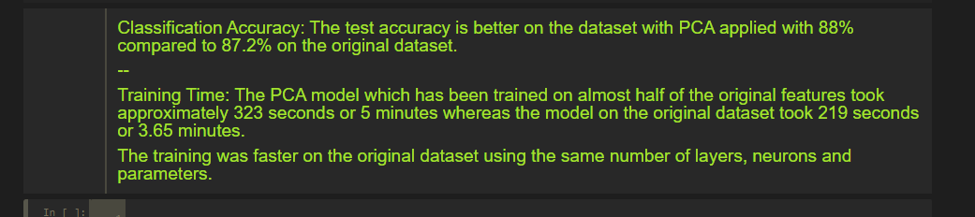

1. Hyperparameter Tuning using RandomizedSearchCV

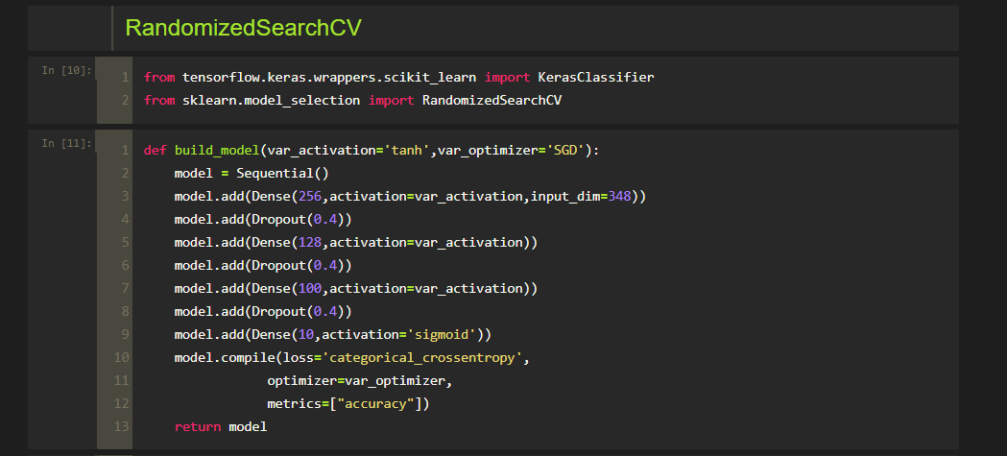

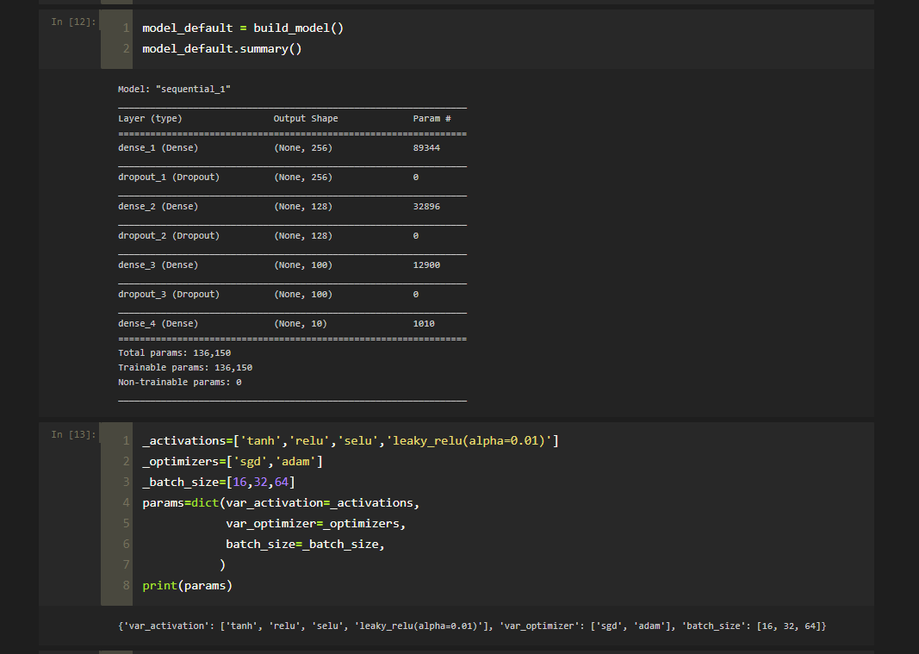

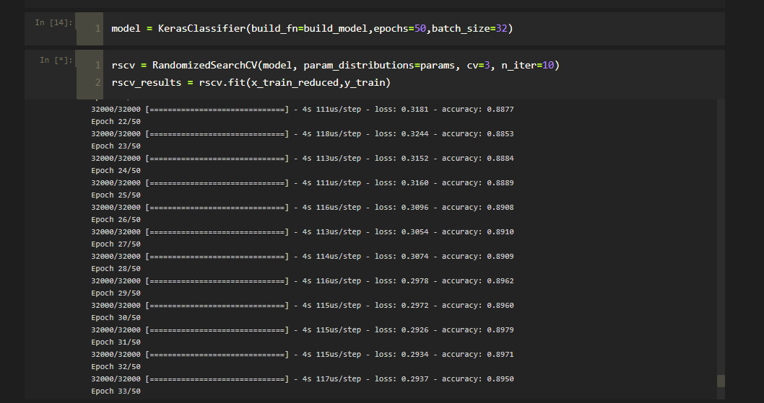

Results – Best parameters and Accuracy

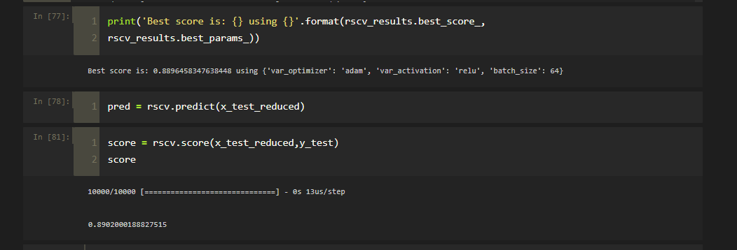

1. Comparing the results of the previous model and the current model

